

Certification Ceremony
Programme
15 November 2014

8:00 – 8:25 | Registration |  | Foyer
8.30- 9.30 | Welcome & background to the project | Mr B Schereka | H3
8.30- 9.30 | Motivation | Dr J Clark | H3
8.30- 9.30 | Musical Item | ThembelihleSSS | H3
8.30- 9.30 | Guest Speaker | Mr B Schreuder | H3
8.30- 9.30 | BCP Teacher | Ms C Snell | H3
8.30- 9.30 | Maths Teacher | Mr D Soboyisi | H3
8.30- 9.30 | Language Teacher | Ms N Mofoka | H3
8.30- 9.30 | ACE Teacher | Ms V Stevens | H3
9:30 – 10:15 | Tea |  | Conf.Cntr
10:30 – 11:30 | Breakaway presentations
10:30 – 11:30 | Mathematics 1 | Ms J Davids | Venue 1
10:30 – 11:30 | Mathematics 2 | Ms G Smith | Venue 2
10:30 – 11:30 | Language 1 | Ms J Philips | H3
10:30 – 11:30 | Language 2 | Ms K Woodward | H3
11:30 –12.30 | Certification Ceremony |  | H3
11.30 – 11. 40 | Musical Item | Violinists | H3
12.30 – 12.35 | Thanks | Ms C Kühne&  Ms U Esau | H3
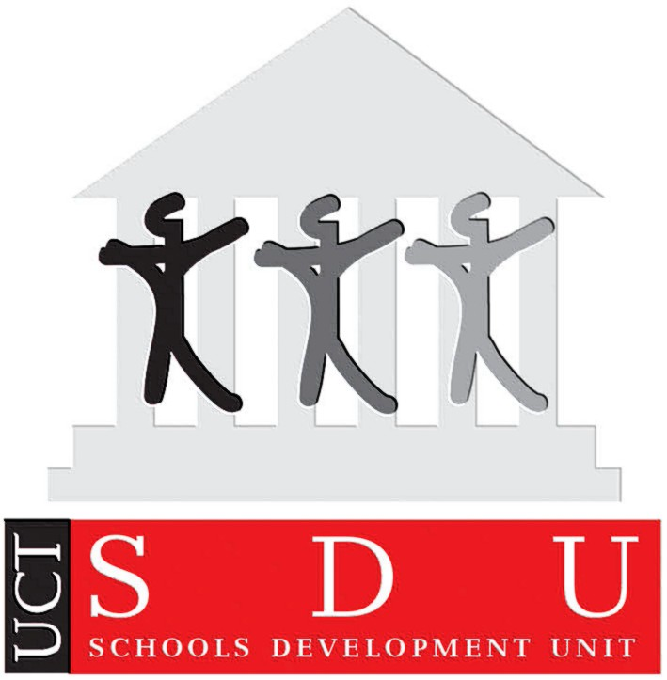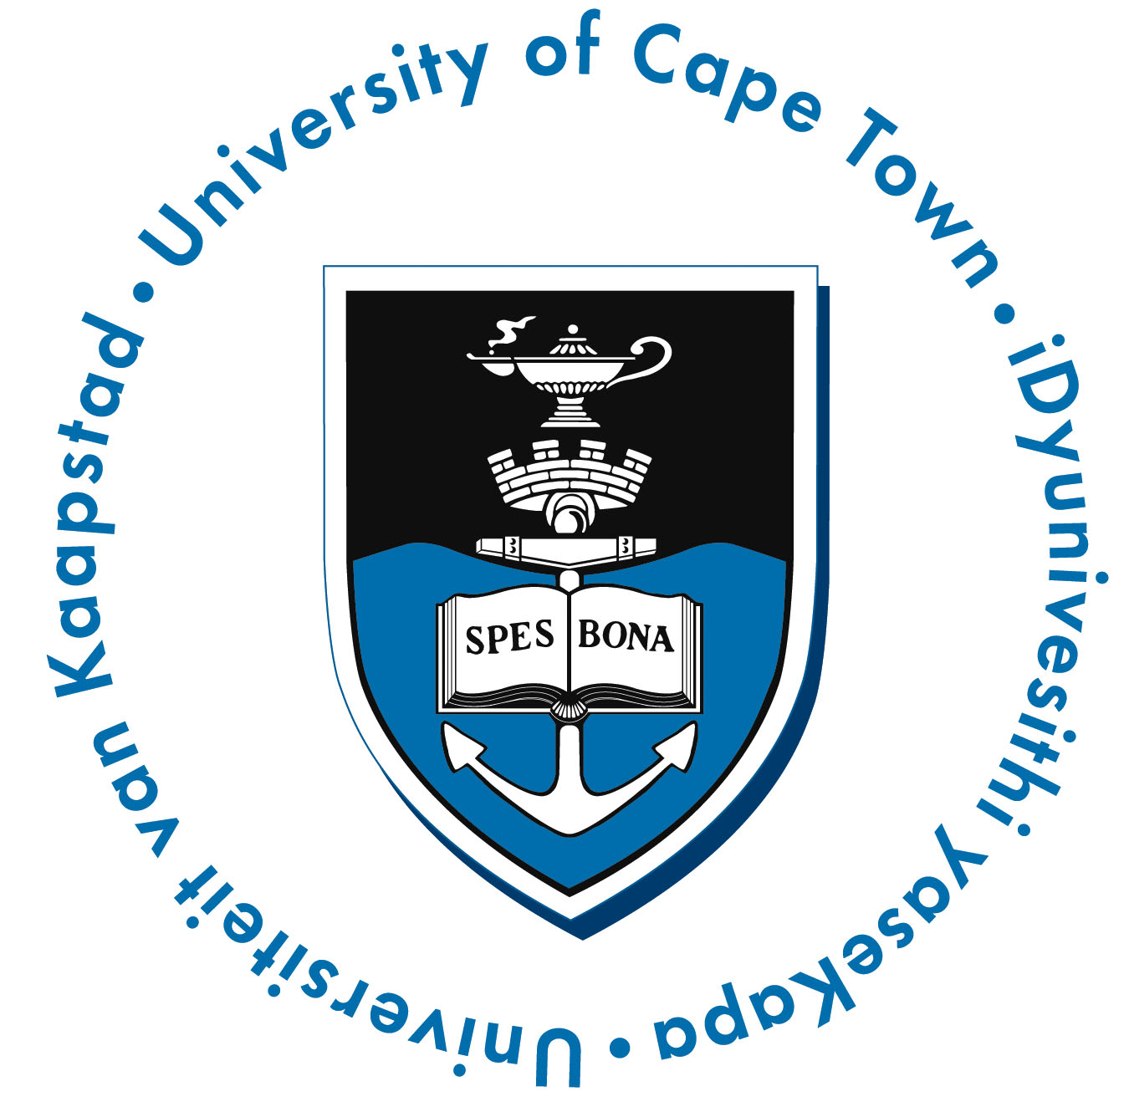
Metropole East Education District
Curriculum Coordination andAdvice

Curriculum Coordination and Advice

