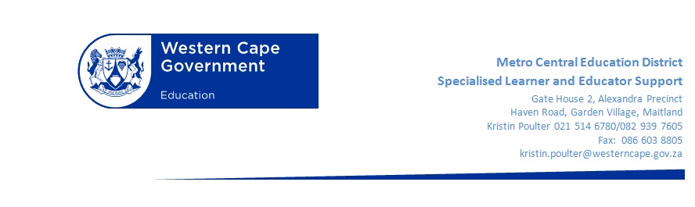



SPECS FOR BCP REFRESHER SESSION WITH LOUIS BENJAMIN

Programme BCP Refresher Session 14 June 2016 2pm – 4:00pm Rylands Primary School (TBC)
2pm-2.15pm | Welcome Tea
2.15pm – 3pm | Live Demo Lesson and Discussion
3pm – 3.30pm | Sharing of Best Practise:  Teachers to share their experiences and learner’s work. Questions asked and answered.
3.30pm – 3.45pm | Basic Concepts Mediator Zone:  WhatsApp Groups and Online Portals
3.45pm – 4:00pm | Thank you and closure

