Carvalho, C. O. (2015). Mapas Pensantes® as a cognitive intervention resource for high school students. Master's thesis, Institute of Psychology. Federal University of Bahia, Salvador.

Mapas Pensantes®, originally called Thinking Maps©, are a set of visual teaching resources associated with cognitive processes used for interventions in learning environments. Currently it is suggested that, when used by teachers in school context, they act as a common language, improving learning and transforming information into knowledge, facilitating communication and sharing of logical thinking. Studies indicate that the use of Mapas Pensantes® promote academic development, expansion of vocabulary, improvement of reading comprehension and mathematical reasoning, as well as developing social and intrapersonal skills.
My study aimed to determine the effects of Thinking Maps on reading comprehension and working memory. The Multi-component Working Memory Model of Baddeley (2012) was used in this study – See figure below. The literature suggests that working memory plays an important role in our cognitive functioning and is considered a good predictor of learning (Alloway & Alloway, 2010; Dehn, 2008; Uehara & Landeira-Fernandez, 2010), since it is responsible for complex cognitive activities, including language comprehension, reasoning and problem solving. It is argued that working memory also has an effect on reading comprehension (Wagner & Ridgewell, 2009) and in turn influences academic performance (Gentaz, Sprenger-Charolles, & Theurel, 2015; Wagner & Ridgewell, 2009). Studies also indicate that the use of visual and verbal resources, including graphic organizers, contributes to the activation of the working memory passive subsystems (visuospatial sketchpad and phonological loop).
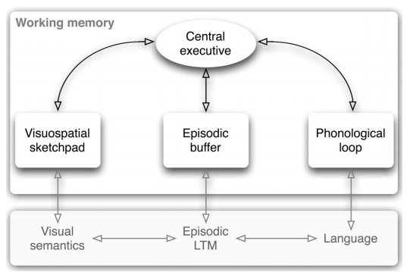
(Figure from REPOVŠ & BADDELEY, 2006)

Mapas Pensantes® is a visual learning system contributing towards enhanced academic performance – because of the parallel use of visual aids, written and spoken language (Edwards, 2011; Hyerle & Alper, 2011; Hyerle, 2009; Lopez, 2011; Manning, 2003) . It is contended that the efficacy of Mapas Pensantes® is related to the activating of the working memory, according to the multicomponent model (Allen, Baddeley, & Hitch, 2014). It is important to understand how the use of Mapas Pensantes® can activate both the phonological loop and the visuospatial sketchpad, for example it is suggested that the processes of binding and chunking information seems to be triggered during the creation of the Mapas Pensantes®. The application of Mapas Pensantes involves both the connection of information sources from different sensory modalities (binding) and the integration of information units into larger agglomerates (chunking).
My research recommends that improved methods should be developed to assess reading comprehension for adolescents and adults in Brazil. Such research would assist to generate better indicators for measuring reading comprehension and thus lead towards the development of more effective intervention strategies.

Examples of the Mapas Pensantes® during intervention research:
1) Thinking of sustainability
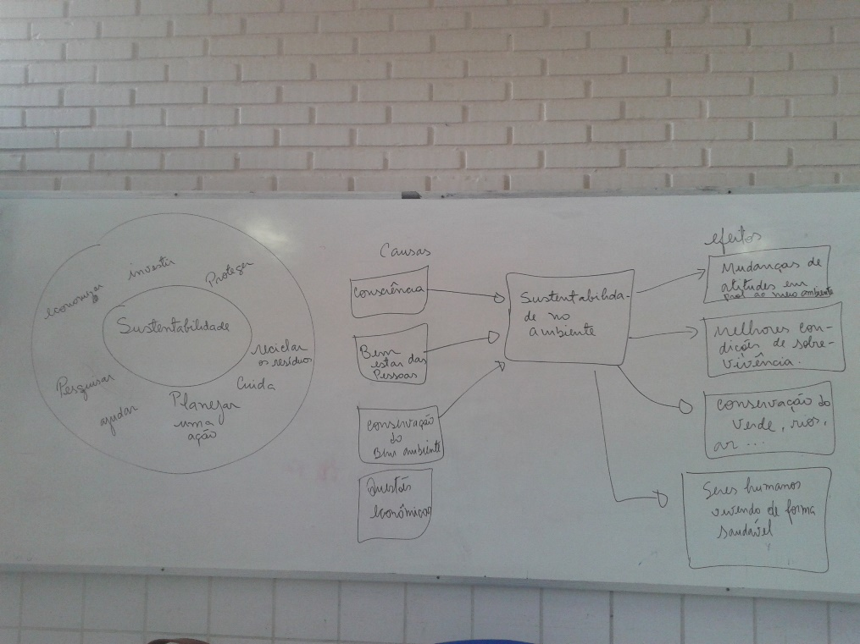
2) Different types of writing
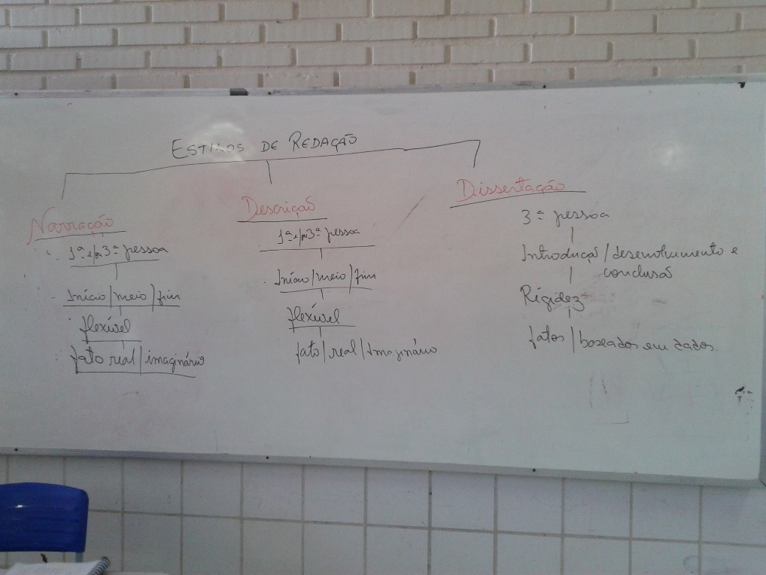

3) Sequencing ideas for writing
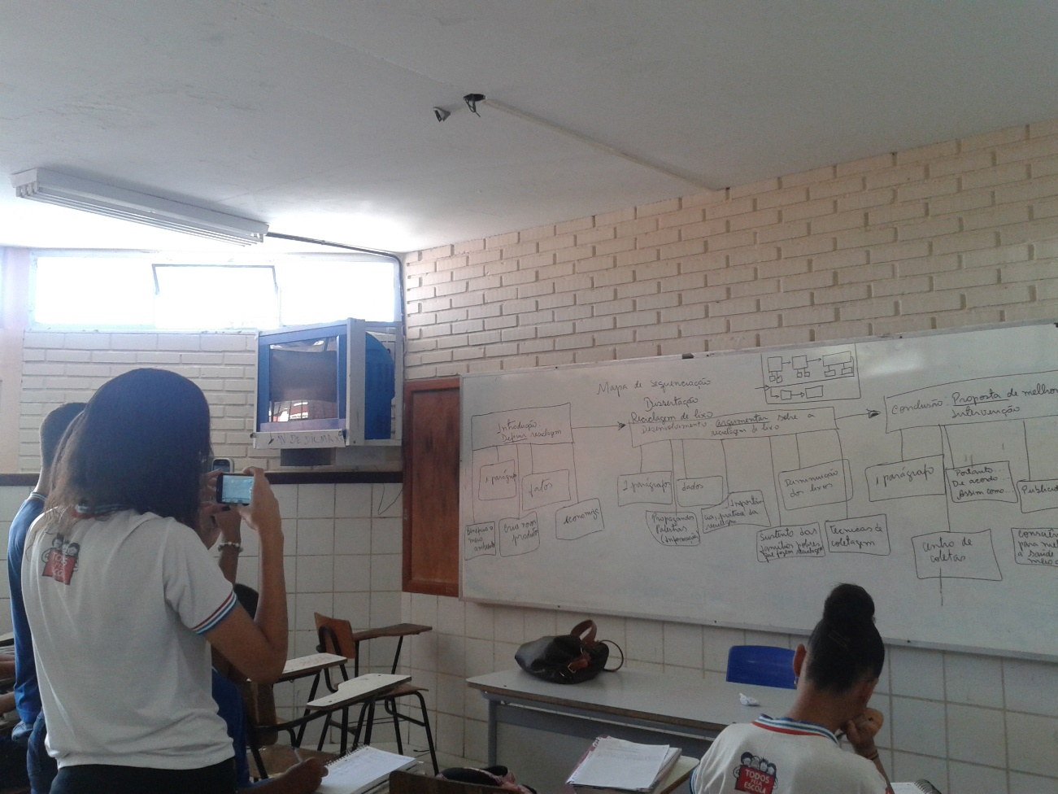

Photo of Carla Carvalho
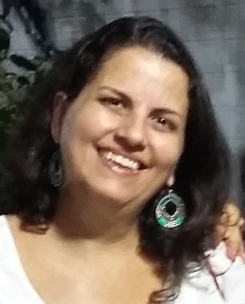

REFERENCES:
Allen, R. J., Baddeley, A. D., & Hitch, G. J. (2014). Evidence for Two Attentional Components in Visual Working Memory. Journal of Experimental Psychology: Learning, Memory, and Cognition, 40(6), 1499 –1509.
Alloway, T. P., & Alloway, R. G. (2010). Investigating the predictive roles of working memory and IQ in academic attainment. Journal of Experimental Child Psychology, 106(1), 20–29.
Baddeley, A. D. (2012). Working Memory: Theories, Models, and Controversies. The Annual Review of Psychology, 63, 1–29.
Dehn, M. J. (2008). Working memory and academic learning: assessment and intervention. Hoboken, New Jersey: Jonh Wiley & Sons.
Edwards, P. (2011). Utilizing Thinking Maps® to Promote Reading Comprehension and Motivation to Read in Urban Elementary School Males. Oakland University.
Gentaz, E., Sprenger-Charolles, L., & Theurel, A. (2015). Differences in the Predictors of Reading Comprehension in First Graders from Low SocioEconomic Status Families with Either Good or Poor Decoding Skills. Plos One, 1–16.
Hyerle, D. (2009). Visual Tools for Transforming Information into Knowledge (2nd ed.). Thousand Oaks, California: SAGE Publications.
Hyerle, D., & Alper, L. (2011). Students Successes with Thinking Maps – School Based Research, Results, and Models for Achievement Using Visual Tools. (2ª edição). Corwin: A Sage Company.
Lopez, E. (2011). The Effect of a Cognitive Model, Thinking Maps, on the Academic Language Development of English Language Learners. St. John Fisher College.
Manning, C. M. (2003). Improving Reading Comprehension through Visual Tools. Eastern Nazarene College. Repovs, G., & Baddeley, A. (2006). THE MULTI-COMPONENT MODEL OF WORKING MEMORY: EXPLORATIONS IN EXPERIMENTAL COGNITIVE PSYCHOLOGY. Journal of Neuroscience, 139, 5–21.
Uehara, E., & Landeira-Fernandez, J. (2010). Um panorama sobre o desenvolvimento da memória de trabalho e seus prejuízos no aprendizado escolar. Ciências & Cognição, 15(2), 31–41.
Wagner, R. K., & Ridgewell, C. (2009). A Large-Scale Study of Specific Reading Comprehension Disability. Perspectives on Language and Literacy, 35(5), 27–31.

